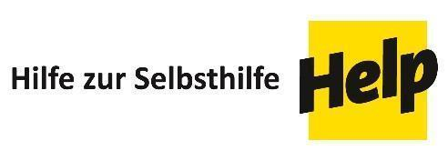
Declaration for Candidates,
Tenderers or Suppliers

Confidentiality
The Candidate/Tenderer agrees to hold in trust and confidence any information or documents discloses to it, discovered by it or prepared by it in the course of or as a result of its participation in the above-mentioned procurement procedure, and agrees that it shall be used only for the purposes of this procedure.

Eligibility
I / We hereby declare that [full name of the Candidate, Tenderer or Supplier]
- is not subject to any conflict of interest in the ongoing procurement procedure for this contract P-SOE-12-23-26-01 with other commitments or contracts recently concluded or to be concluded either individually or through any consortium to which it might belong or through any subsidiary or related company;
- is not bankrupt or being wound up or having its affairs administered by the courts. It has not entered into an arrangement with creditors or suspended business activities and is not the subject of proceedings concerning those matters. Neither is it in any analogous situation arising from a similar procedure provided for in national legislation or regulations;
- has never been convicted of any offence concerning its professional conduct by a judgment which has the force of res judicata;
- has never been proven guilty of any grave professional misconduct;
- has never failed to fulfil its obligations relating to the payment of social security contributions or the payment of taxes in accordance with the applicable legal provisions of the country in which the Tenderer/Candidate/Supplier is established or with those of the country of the Contracting Authority or those of the country where the contract is to be performed;
- has never been the subject of a judgment which has the force of res judicata for fraud, corruption, involvement in a criminal organisation or any other illegal activity, including coercive or collusive activities, detrimental to the Contracting Authority or the European Union's financial interests;
- is not currently subject to an administrative penalty
- is not currently subject to any administrative penalty imposed by an EU funded donor, by a UN Agency or by any other of the Contracting Authority’s donors
- partners for
  - being found guilty of misrepresentation in supplying the information required as a condition of participation in a procurement procedure or failing to supply this information; or
  - being declared in serious breach of contract for failure to comply with the contractual obligations.

Data Protection
I / We hereby declare that we agree to the Contracting Authority processing personal data in the context of the procurement process and any contractual agreements that might result out of it. According to article 15 GDPR (General Data Protection Regulation), you have the right to request disclosure of all personal data, that the Contracting Authority processes and stores at any time. According to article 17 GDPR you have the right to request the revision or deletion of personal data. Any such requests or the revocation of this declaration need to be addressed to the Contracting Authority in writing.

Company name:
Full name and position of signatory:
Date:
Signature and stamp:

