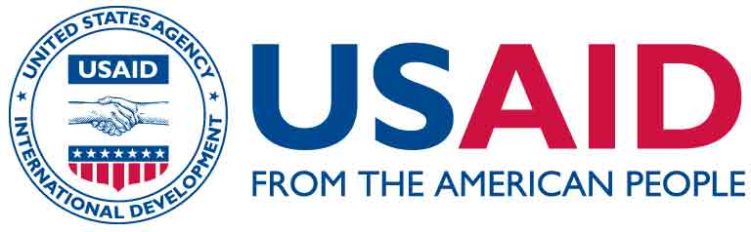

TERMS OF REFERENCES FOR LOCAL CONTRACTOR
PROMOTING FORMAL ADOPTION OF THE WBMP FOR SOUTHERN WATER BASIN MANAGEMENT AREA OF ARMENIA THROUGH THE SUPPORT IN THE PROCESS OF ENVIRONMENTAL IMPACT STRATEGIC ASSESSMENT AND EXPERT EXAMINATION
FEBRUARY 2024
- Financing
USAID financed “Armenia Improved Water Management for Sustainable Economic Growth Program”, Contract No. 72011122C00001

- Procedure
Simplified procedure according to Deloitte’s micro procurement
- Contracting Authority
Deloitte Consulting Overseas Projects LLC - Armenia
- Nature of contract
Service contract
- Period of implementation
March 15th - December 15th, 2024
- Contract price
Up to USD 10.000 (equivalent AMD). Price should not include VAT.

- Background information
- Background and Objectives
The USAID Armenia Improved Water Management for Sustainable Economic Growth (AIWM) Program, implemented by Deloitte Consulting LLP, aims to strengthen Armenia’s water management to improve the equity of access to water while maintaining water quality for the protection of freshwater resources. The Program intends to achieve this goal through the following interlinked objectives:
- Objective 1: Application of Advanced Technologies and Tools to Support Sustainable and Secure Water Management
- Objective 2: Improved Water Governance
- Objective 3: Promote and Scale Best Practices and Innovative Approaches in Water Conservation and Use to Increase Equitable Access to Water Resources
- Objective 4: Preparing for Regional Cooperation with Neighboring Countries
- Objective 5: Improved Access to Water
Under Objective 1 there are four Expected Results:
- Technical Assistance for Improvements in the Monitoring of Water Availability and Use/Allocation
- Support for Data-Driven Water Modelling, Planning, and Decision-Making Support for Evidence-Based Water Allocation and Management at National, Regional, and Selected Basin Levels
- Support for Increased water resource management transparency and accountability at the national and basin levels using modern technology and innovation.
- Enabling and Providing Enhanced Engagement with Academia, Universities, Research Institutions, and the Private Sector for the Development and Application of Modern Water Management Tools

- Scope of work
The main objective of this assignment is to promote the adoption of the Water Basin Management Plan for the Southern Water Basin in Armenia (4506 km², see map in annex 1) by providing expertise and support to conducting the Environmental Impact Strategic Assessment and expert examination process.
Prioritizing the update of water basin management plans, especially in the Southern Water Basin, is a proactive step to align management strategies with evolving regional needs and challenges. For these plan updates, it will be important to include a wide range of stakeholder engagement to better understand the regional needs around water management.
The Southern Water Basin Management Plan (WBMP) is being developed with the support of the USAID-funded “Armenia Improved Water Management for Sustainable Economic Growth (AIWM)” Program, with the active participation of the Ministry of Environment (MOE) of the Republic of Armenia (RoA).
According to the RoA Water Code, the WBMPs shall be adopted by a Government of Armenia Resolution. The formal adoption procedures, among other things, include undergoing an environmental impact strategic assessment and expert examination at the “Environmental Impact Expertise Centre” State Non-Commercial Organization, as required by Article 17th (Examination) of the Republic of Armenia Law “On Environmental Impact Assessment and Expert Examination” (dated 03.05.2023), and require compliance with the Government of Armenia Resolution N 2294-N “On Approval of Procedure for Conducting Strategic Environmental Assessment and Requirements for Strategic Environmental Assessment Report” (21.12.2023) and Government of Armenia Resolution N 2343-N "On Order of Public Notification and Discussions” (dated 28.12.2023). According to Article 33 of the Law, a state fee shall be levied for carrying out an expert examination process.

Procedures of Environmental Impact Strategic Assessment and Expert Examination in Armenia
The procedures of environmental impact strategic assessment and expert examination of the Southern WBMP for Southern Water Basin Management Area (WBMA) of Armenia and corresponding public hearings are regulated by Article 28th of the Republic of Armenia Law "On Environmental Impact Assessment and Expert Examination” and Government of Armenia Resolution "On Order of Public Notification and Discussions”.
It is expected that the consultant will support the Program and the MOE of RoA in organization of two rounds of public notification and hearings according to Article 28 of the above-mentioned Law and preparation of the application of preliminary assessment and environmental impact strategic assessment report for the WBMP for Southern WBMA. The service provider should work closely and collaborate during the whole period of the service provision with the regional governor's office/s concerned with the Southern WBMA. The service provider for conducting the Environmental Impact Strategic Assessment and expert examination process shall pay, a state fee in the manner and amount established by the legislation of the Republic of Armenia.
- Deliverables & format
The following three deliverables will have to be produced during the assignment:
Deliverable 1: Environmental impact assessment (EIA) preliminary report, including the materials of the properly organized and implemented 1st round of public notification and hearing, in accordance with Article 16th of the RoA Law "On Environmental Impact Assessment and Expert Examination” (updated on 03.05.2023) and RoA Government Resolution "On Order of Public Notification and Discussions” (updated on 03.05.2023). Proceedings of public hearing meetings: (i) on the WBMP Southern WBMA; and (ii) on strategic assessment/environmental impact assessment of the WBMP for Southern WBMA.

Deliverable 2: Environmental impact assessment (EIA) report, including the materials of the properly organized and implemented 2nd round of public notification and hearing, in accordance with Article 17th of the RoA Law "On Environmental Impact Assessment and Expert Examination” (2014, updated on 03.05.2023) and RoA Government Resolution "On Order of Public Notification and Discussions” (updated on 28.12.2023).

Deliverable 3: Positive expertise conclusion facilitated.
The Contractor will address the comments received from Governmental agencies after reviewing the EIA document, finalize it, along with preparing a summary sheet with clarifications on revisions made in the document per comments received.

The reports and deliverables will have to be submitted in English and Armenian languages.
- Schedule & implementation modality IV.1. Schedule
The duration of the assignment will be from March 15th to December 15th, 2024. Detailed timeline for submission of deliverables is presented in the Table below.
# | Deliverable | Due Date
1 | Environmental impact assessment (EIA) Preliminary Report, including the proceedings of 1st public hearing meetings. | July 30, 2024
2 | Final Report of Environmental impact assessment (EIA), including the proceedings of 2nd public hearing meetings. | August 30, 2024
3 | Positive expertise conclusion facilitated and a summary sheet on addressing the comments received from the Governmental agencies prepared. | December 15, 2024

Payment for the deliverables shall be considered only when the work is accepted by the Program team on behalf of the country's beneficiaries.

IV.2. Implementation modalities
Works shall be implemented by a licensed Armenian company or group of NGO(s), universities, research institutions, etc. that do not represent the project beneficiaries. The assessment will be closely coordinated, assisted, and monitored by the Program team and the MOE of RoA (Water Resources Management Department and Water Policy Department). Close coordination shall be ensured with the beneficiaries who will take full ownership of the documents produced. The MOE will provide all the required baseline data and documents to the service provider. The service provider should have at least 4 years of proven experience in environmental impact assessment and involvement in the expert examination processes as an initiator or in another role. The potential service provider should have also proven experience in at least 3 cases experience in environmental impact strategic assessment and expertise involvement for concept documents, at least 1 of which should be in the sector of WBMPs.
The Contractor must designate competent specialists for each part of the assignment as well as a coordinator who is responsible for managing these specialists, harmonizing the documents, and informing the Program team.

Contact details:
Representative of the USAID/Armenia Improved Water Management for Sustainable Economic Growth Program: Mr. Armen Varosyan, Chief of Party (COP), armen.varosyan@armeniaiwm.am.

- Participation in the tender
Interested parties (individual and legal persons) are invited to inquire full tender dossier containing instructions and further information about the tender procedure from Ms. Astghik Ohanyan, Program Coordinator, astghik.ohanyan@armeniaiwm.am

The deadline for submission of the technical and financial offer is 29 February 2024, 18:00 Yerevan, Armenia time.
LIST OF ANNEXES

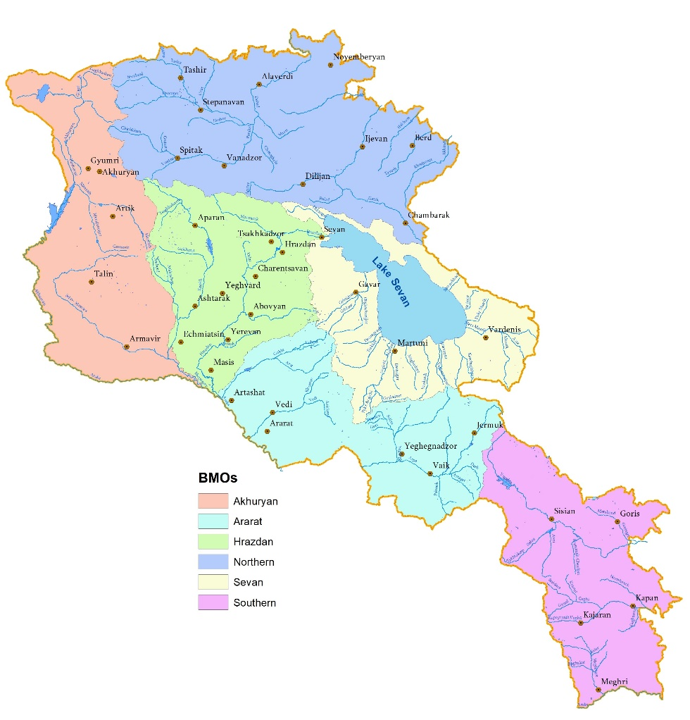
Annex 1: Map of Southern water basin

https://www.arlis.am/documentview.aspx?docid=178443
https://www.arlis.am/DocumentView.aspx?docid=187701
https://www.arlis.am/documentview.aspx?docid=188064

