Office Yerevan

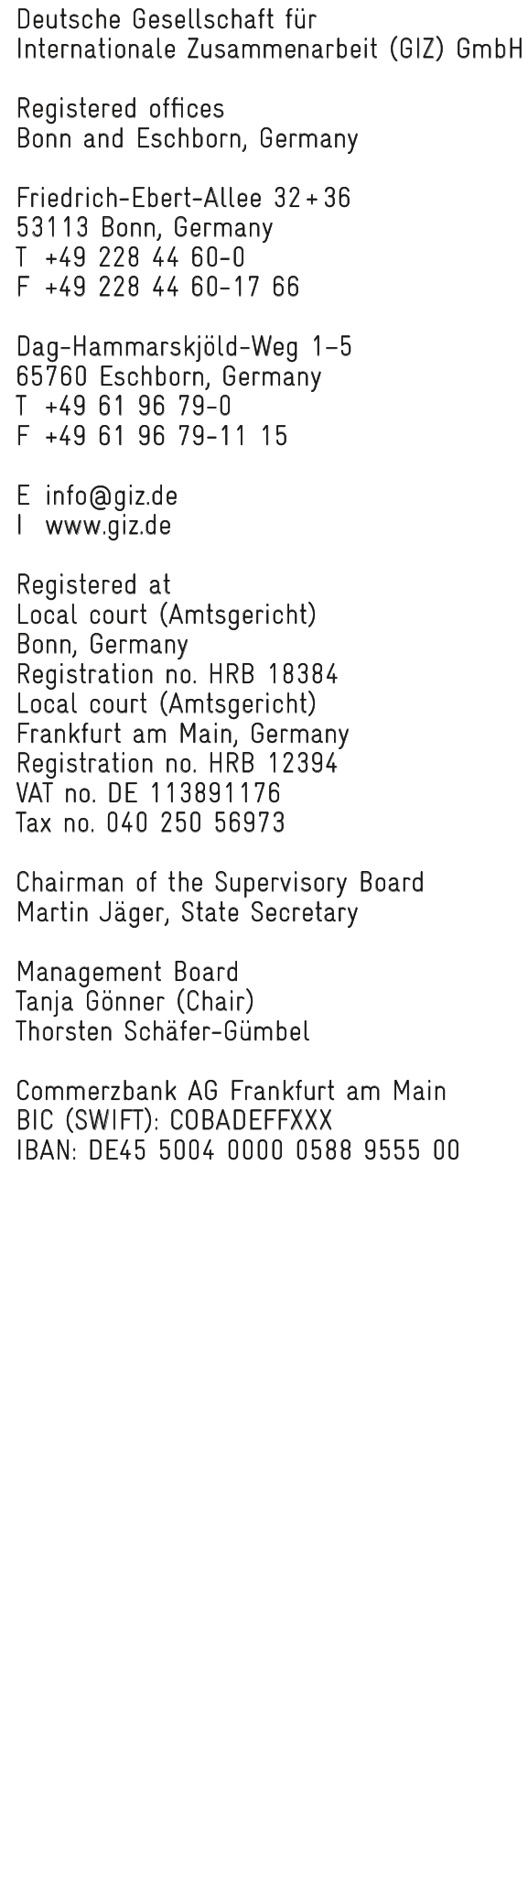

German development cooperation
GIZ Office Yerevan

59 Hanrapetutyan Str.
0010 Yerevan,
Republic of Armenia
T +374 10 510060
E GIZ-Armenia@giz.de

Ihr Zeichen
Unser Zeichen
Your ref.  Our ref.  Email ellada.martirosyan@giz.de | Phone +374 10 51 00 60-117  +374 99 43 22 88  Date 27.04.2020

Transaction number: CoV 03 /20
Processing no.: 16.2179.6-009.00
Project title: Private Sector Development and TVET South Caucasus The EU4Business “Innovative Tourism and Technology Development for Armenia” project
Country: Armenia

Dear Sir/Madam,
We intend to award contract to a consulting company for Concept development for attracting regional and international tech and entrepreneurship talent. The detailed ToR of the assignment in English is attached to this Call for Proposals.
If you are awarded the contract, you are not excluded from bidding for the implementation of the following project phase. However, a prerequisite for participation in a subsequent tender is that you do not benefit from your involvement in the previous contract and that the equal treatment of all bidders is ensured.
Submission deadline
If you are interested in performing this work, please submit a bid in accordance with the GIZ bidding conditions described below till 12.05.2020, 18:00 (date of receipt at GIZ).

Your bid may be submitted (A) electronically or (B) as hardcopy.
A – Electronical offer
Your bid, comprising the technical offer (company’s background, relevant experience, CVs of involved experts etc. (see also TOR § 3.3 and 3.5)) and the price offer (calculation based on Expert days), must be clearly marked as such and submitted as two separate emails. Please send your bid to AM_Quotation@giz.de with the following subject line:

• "Technical offer" with the subject line: CoV 03 /20 Technical Offer:
• “Financial Offer” with the subject line: CoV 03 /20 Financial Offer:

B – Submission of hardcopy
Your bid, comprising the technical offer (company’s background, relevant experience, CVs of involved experts etc. (see also TOR § 3.3 and 3.5)) and the price offer (calculation based on Expert days), must be clearly marked as such and submitted as a package containing two envelopes.
The price offer must always be separate from the technical offer and placed in a separate envelope. The envelope containing the price offer must be sealed and be labelled as follows:
Price offer from [please note sender] for: Private Sector Development and TVET South Caucasus: The EU4Business “Innovative Tourism and Technology Development for Armenia” project CoV 03/20
PN: 16.2179.6-009.00
– to be opened by Contracting department –

The technical offer must always be separate from the price offer and placed in a separate envelope. The envelope containing the technical offer must be sealed and be labelled as follows:

Technical offer from [please note sender] for: Private Sector Development and TVET South Caucasus: The EU4Business “Innovative Tourism and Technology Development for Armenia” project CoV 03/20
PN: 16.2179.6-009.00
– to be opened by Contracting department –

The outer package must be labelled as:
Bidding documents for [please note sender]: Private Sector Development and TVET South Caucasus: The EU4Business “Innovative Tourism and Technology Development for Armenia” project CoV 03/20
PN: 16.2179.6-009.00
– to be opened by Contracting department –
and be addressed to:
Deutsche Gesellschaft für Internationale Zusammenarbeit (GIZ) GmbH
Country Office Armenia
59 Hanrapetutyan str., 8th floor, 0010 Yerevan, Armenia
Don’t forget to specify contact person and details on the outer envelope!
Price offer
The price offer must be submitted in AMD. Based on the Decision of the RA Governance Nr. 1112-Ն of 23.09.2009 GIZ is VAT excepted. The price offer should be submitted without VAT.
Procedural questions
Please address any commercial, technical and procedural questions at an early stage. Questions will be answered if they are received at the latest two working days before the closing of the tender. Questions have to be raised in writing by email only to:
Mrs Ellada Martirosyan
email: ellada.martirosyan@giz.de
Non-compliance may result in your bid not being considered.
Evaluation of Offer
We will evaluate the technical and price information in the received bids (see Annex).
After the technical evaluation, only the price offers of bids with more than 500 points will be opened and evaluated. Technical offers below 500 points will be considered as technical not acceptable. The technical offer has a weighting of T: 70%, the price offer F: 30%. The following formula will be used:
$$\frac{\text{technical evaluation of bid x T}}{\text{technical evaluation of best bid}}\text{+}\frac{\text{most economical bid x F}}{\text{price of bid}}$$
The final result is an overall ranking, headed by the most cost-effective bid. Contract negotiations will be initiated on the basis of this overall ranking.

Yours faithfully,
Deutsche Gesellschaft für
Internationale Zusammenarbeit (GIZ) GmbH

Ellada Martirosyan
Contract Management
(electronically mailed without signature)

Annexes
- Terms of Reference
- Assessment grid
- General Terms of Contract

